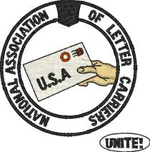
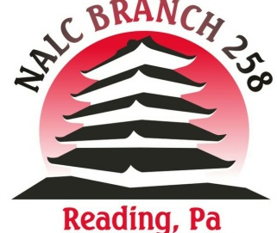
Hoagie Sale Fundraiser
Benefits the Beck & Bear Scholarship Funds
All hoagies are LARGE, on HARD rolls, and cost $7.00 each.
Order & money are due by Tue. May 17th. Hoagies will be made & distributed on Fri. May 20th.
Thanks to Frank’s Pizza for making this fundraiser happen!

Name  (first & last) | Ham $7 | Turkey $7 | Italian $7 | With Cheese | Lettuce | Tomato | Onion | Pepper Spread | Mayo | Oil and Vinegar | Total Amount Due
1
2
3
4
5
6
7
8
9
10
11
12
13
14
15
16
17
18

